How to Use Beagle Bone Drone

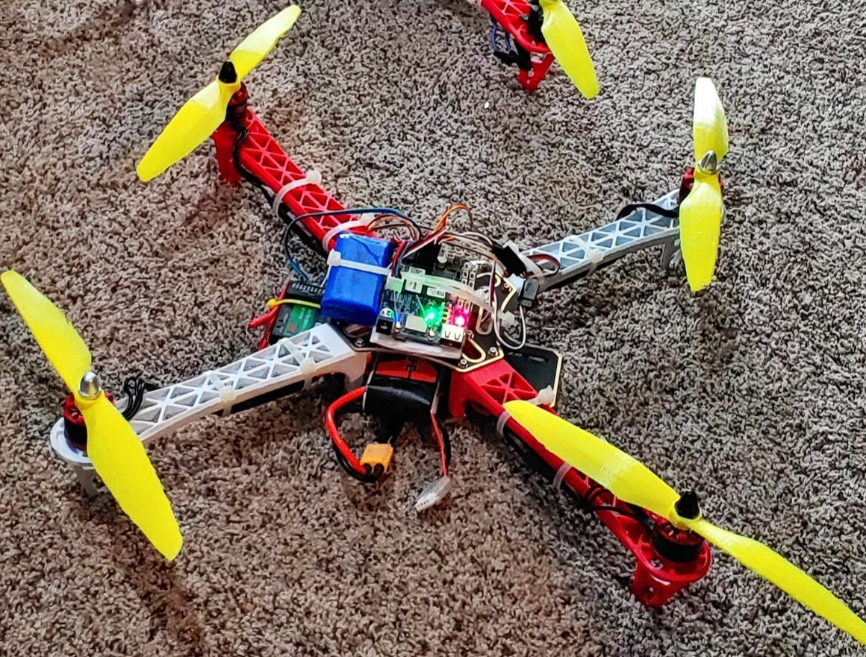

Table of content

1. How to startup Beagle bone Drone
2. Drone Check List
3. How to use mission planner
4. Raspberry Pi Interfacing
5. Controller Setup

Setting up the Beagle bone drone

To setup the Beagle bone drone you will need-

* Beagle bone Drone
* LIPO Battery (3S)
* Remote Control
* Laptop Computer
  + Charged
  + Wifi Connection

Drone Check list

|  |  |  |
| --- | --- | --- |
| Date: Location: | Check | Comments |
| Charged Battery |  | Volts: MAH: |
| Check props tight on motor |  |  |
| Secure battery and cargo |  |  |
| Plug in battery |  |  |
| Check Radio Connection on mission planner |  |  |
| Check surroundings of drone operation area |  |  |
| Arm Drone |  |  |
| Landed |  |  |

Comments on flight:

Crashed drone : Yes or No and # ___ and comment:

**Connecting Radio Receiver W/ ppm**

The ppm channel on the receiver should be clearly labeled and is the last pin. The brown cable which is soldered onto a yellow cable will be the signal wire. The red cable will provide power to the radio receiver and the gray cable will be the ground wire for the system. On the radio receiver the order they should plug in is signal-power-ground on the ppm row if you plug in from the top.

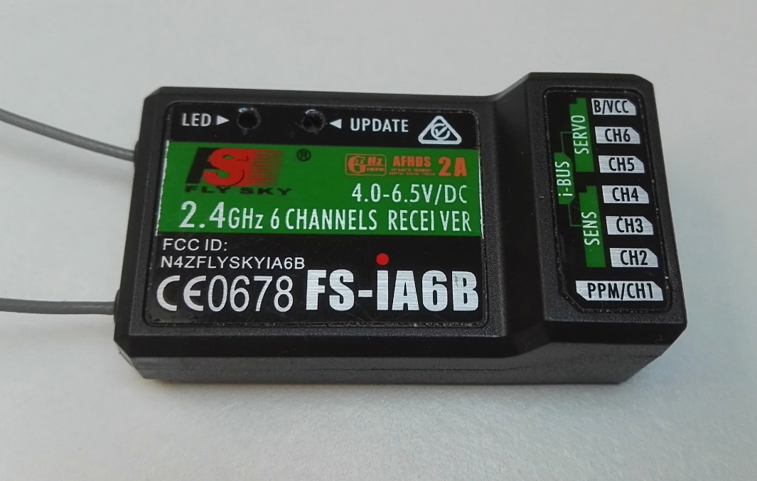

Using putty

Putty is a ssh’ing program that will allow you to remotely connect to the Beagle Bone board. This program is available at <https://www.chiark.greenend.org.uk/~sgtatham/putty/latest.html>

To connect via putty you will 1) open up the putty application 2) Type the ip address of beagle bone in host name text box (if plugged in via usb the ip is 192.168.7.2). 3) Hit the open button and you should be greeted by a login screen if not the Beagle Bone is still booting up. The login info by default is (username: debian),(password : temppwd). 4) To manually start the Beagle Bone program you will want to enter the following commands.

* /bin/echo 80 >/sys/class/gpio
* /bin/echo out >/sys/class/gpio/gpio80/direction (will get a ‘no such file or directory’ back, ignore this)
* /bin/echo 1 >/sys/class/gpio/gpio80/value (will get a ‘no such file or directory’)
* /bin/echo pruecapin_pu >/sys/devices/platform/ocp/ocp:P8_15
* CONNECT TO WIFI STEPS
  + sudo connmanctl
  + enable wifi
  + scan wifi
  + services (will show the ssid in your area with wifi name)
  + agent on
  + connect wifi_f8d
    - Where wifi_f8d is your ssid that you can see after the services step
* sudo /home/debian/arducopter -C udp:192.168.1.16:14550
  + replace 192.168.1.16 with your laptops ip address
  + enter password temppwd upon prompting (if you see weird matrix’y characters start coming up after hitting enter you did it right)

How to use Mission Planner

Screenshot of Mission planner (1.3.68)

Mission planner is the software that is used to control the drone. It has a lot of different options that can be used to tune the drone flight model. This can highly change how the drone flies but if the drone is already setup mission planer is easy to use.

The first thing you’ll want to do is go thru the checklist provided and make sure drone flight is ready. When you are ready to connect to drone, you’ll chose the correct connection info for this it will be (look for the dropdown next to the connect button, default is AUTO) udp then hit the connect button. Press ok on the popup about the listern port. The drone’s information will load onto the laptop thru the WIFI. This will allow us to arm the drone and the drone’s motors will start to spin up and it will be ready to fly. Be careful to keep the drone within the WIFI signal zone to enable good connection.

NOTE: The motors won’t start spinning until you select ‘arm’ on the ‘Actions’ tab in adupilot. Similarly they won’t stop spinning until you disarm.

Controller setup

Binding controller to receiver: <https://youtu.be/9-Z0rTVEkHI?t=80>